US Bases in Australia

Pine Gap, near Alice Springs.

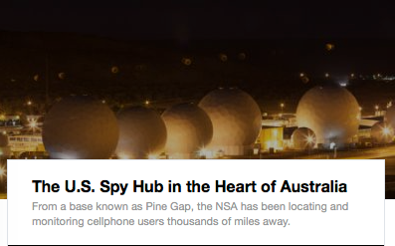

The U.S. Spy Hub in the Heart of Australia
Or see: https://theintercept.com/2017/08/19/nsa-spy-hub-cia-pine-gap-australia/

